Signal Wiring
Thelio Main
Spec version 3

All wire lengths specified from the inside of the connectors.

EXAMPLE IMAGE

Front Ports and Power

CABLE 1
Front panel power button to the backplane (Thelio-IO). 140mm 4-pin dupont to 4-pin dupont. Black connector. Multicolor 28 AWG wire.

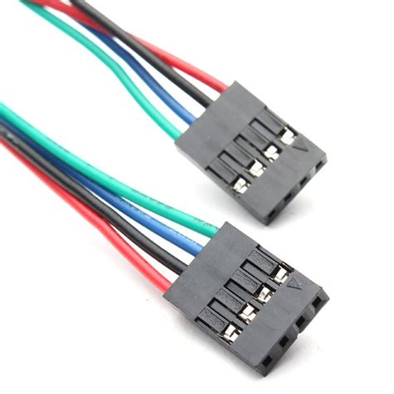

CABLE 2
Power button board to front panel. 70mm 4-pin dupont to individual 2.8mm spade with clear insulated sleeve. Multicolor 28 AWG wire.

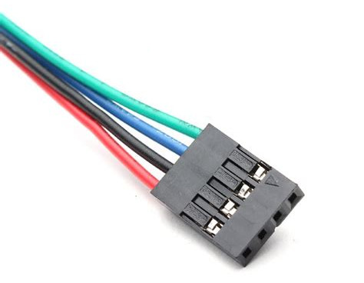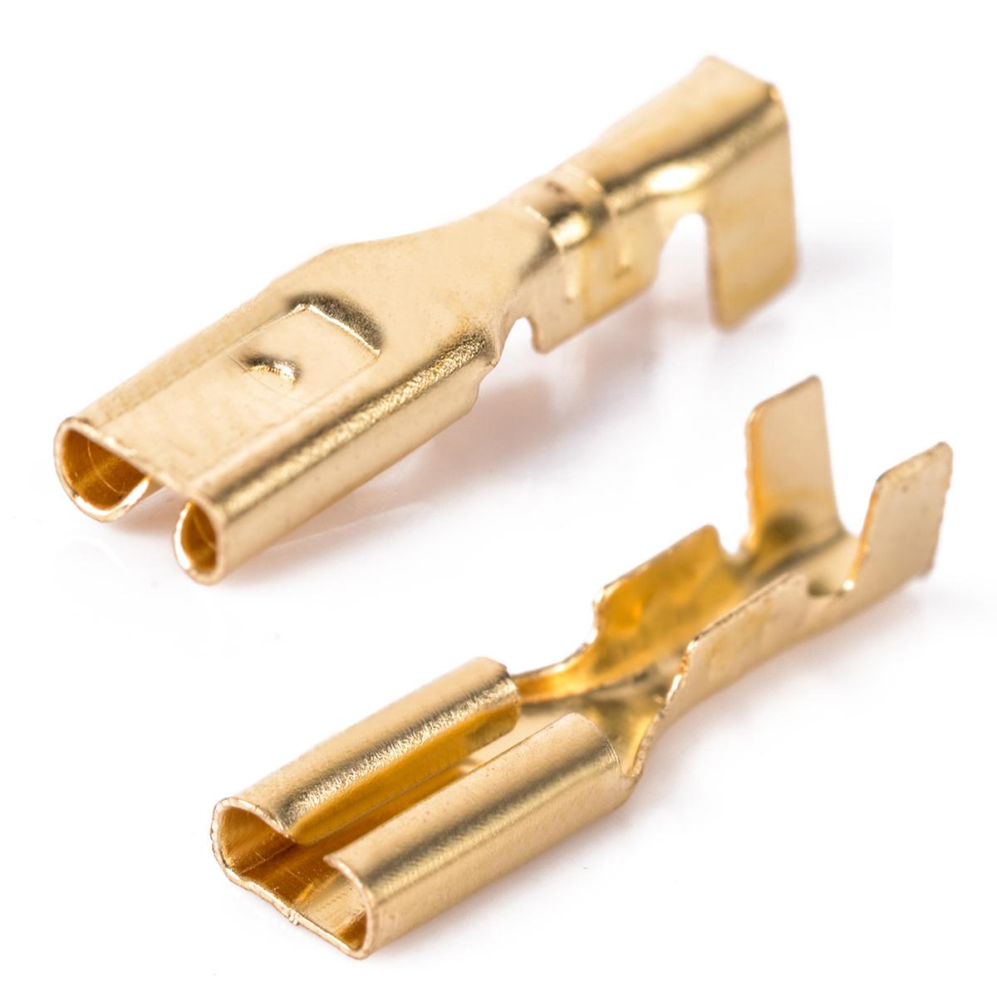
Backplane (Thelio-IO) to/from Motherboard

Backplane (Thelio-IO) 4-pin dupont to motherboard front panel header (2 x 2-pin dupont). 500mm multicolor 28 AWG wire.

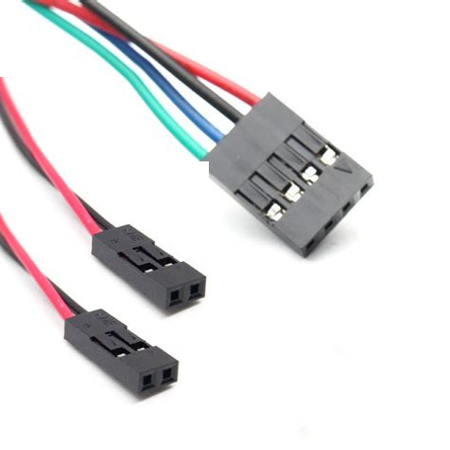

CABLE 3
Motherboard CPU 4-pin female fan connector to backplane (Thelio-IO) 4-female fan connector - 390mm black 28 AWG wire.

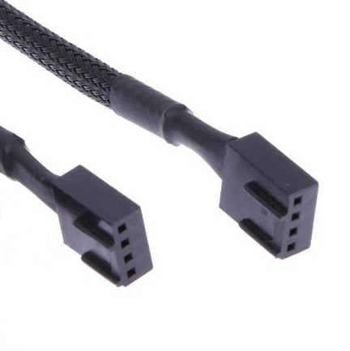

CABLE 4
Backplane (Thelio-IO) backplane USB to 2x 4pin dupont connector. 470mm standard USB 2.0 header to USB 2.0 header.

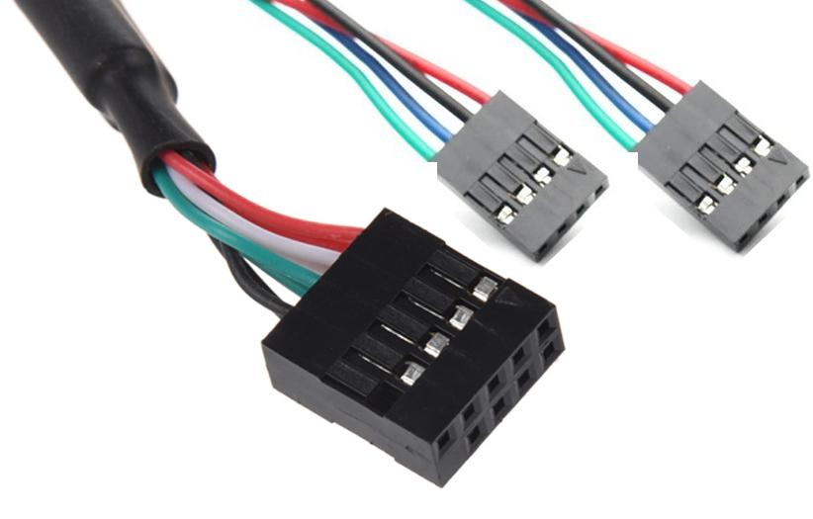

CABLE 5
285mm fan female connector to male connector.

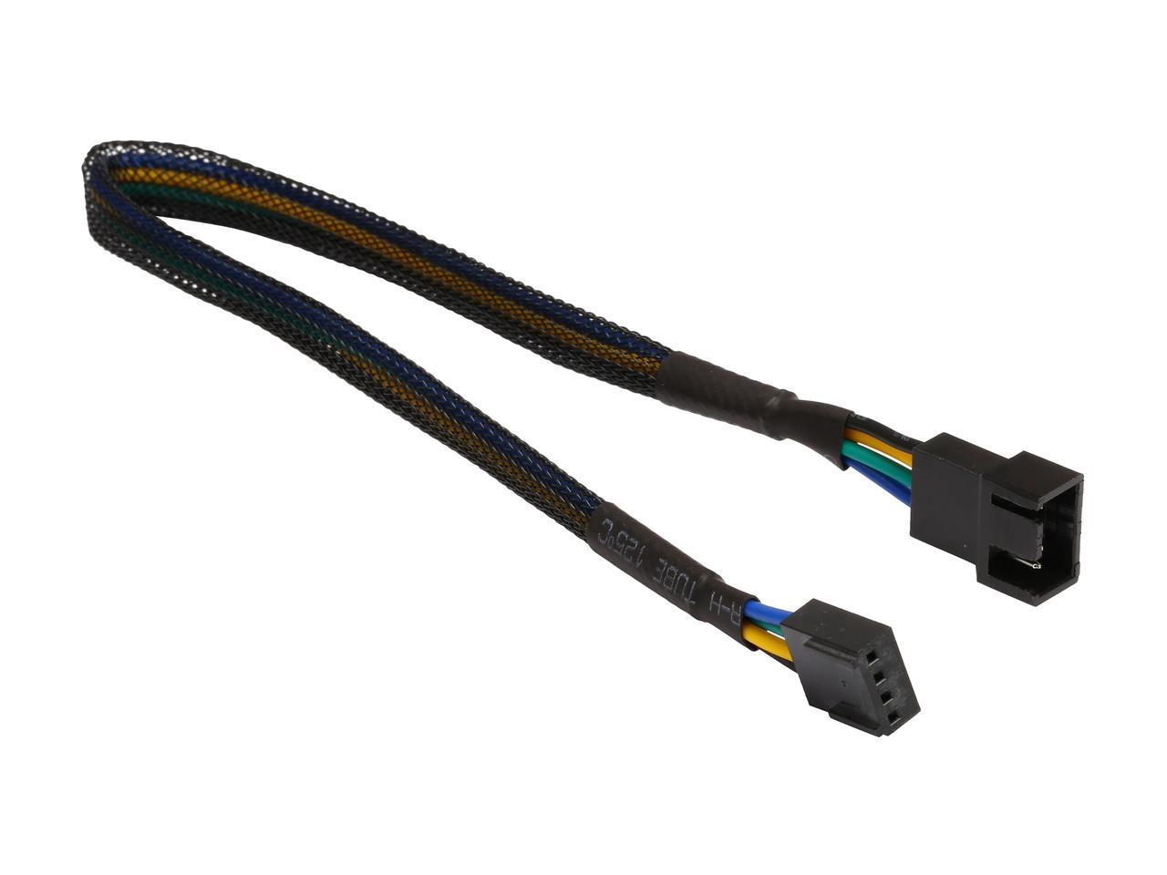

CABLE 6
Molex to dual floppy power connector. One floppy drive connector wire is 150mm in length. The second is 195mm. Black wires and connectors.

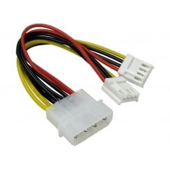

CABLE 7
Wireless Antenna
330mm from the wireless card MHF4 connector to the antenna connect point. MHF4 connector quality and proper crimping of the connector is essential. The connectors should not easily pop off of the terminal.

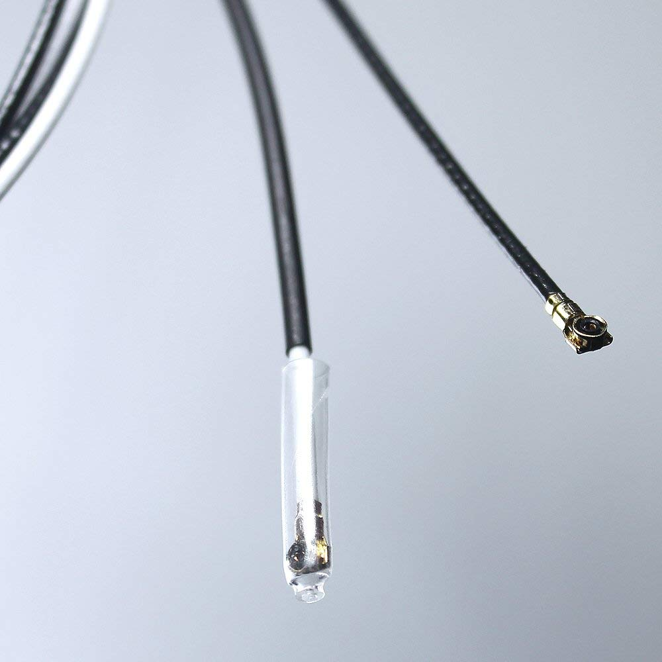

CABLE 8
SATA
Each Thelio Major:
4 x 220mm straight to straight. Black.
4 x 340mm straight to straight. Black.

